Basics of Uncertainty and Error Bars
In any experiment where measurements are made there will always be an uncertainty for each of the measurements.

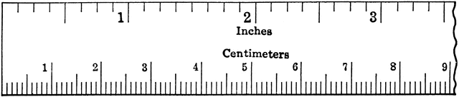

How long is the string shown above, lined up against the ruler?

______ cm

You could not guarantee with 100% certainty that this is in fact the string's length. There are two reasons why this is not the exact length of the string.

  - Reason for uncertainty 1: Precision of measurement
Every measurement has a level of precision. You may have recorded the length of the string as somewhere around 7.7 cm. But would you be comfortable saying the string has a length of 7.735612 cm? You could not say this because it is much more precise that what can be measured using this ruler. The general rule for uncertainty due to the precision of the measuring instrument is ±0.5 units of the smallest marking/interval on the instrument used.

Examples of uncertainty due to instrument precision:
- The ruler above has an uncertainty of ±0.05 cm because the smallest markings show 0.1 cm.
- The uncertainty of a thermometer scale showing every degree will be ±0.5 ⁰C

The uncertainty due to instrument precision is random. This is why the error is shown as ± as the actual data may be more than or less than the recorded value.

  - Reason for uncertainty 2: Techniques used in the experiment
It is an issue that the above string is not straight while taking the measurement. To make it straight we could pull it from either end. But if the string has some elasticity this may make the string longer than it normally is without being pulled. The way a measurement is taken can contribute to the uncertainty of the measurement. Assigning a value to how much uncertainty is introduced due to technique is not always clear-cut but usually assumptions can be made.

Examples of uncertainty due to technique (estimated):
  - Human reaction time using a stopwatch has an uncertainty of ±0.2 s
  - Watching where a long jumper lands by eyesight has an uncertainty of ±10 cm
  - Holding onto a rope trying to provide a constant tension (as opposed to tying it to a pole) has an uncertainty of ±5 N

In these examples it would not matter if the stop watch measured in 0.001 second intervals or if the ruler had 1 mm increments. The uncertainty due to the technique used to measure or control the experiment trumps the precision of the measuring instrument because it is larger. We do not care about a ±0.05 cm uncertainty in the precision of the ruler when we are uncertain about where the long jumper actually landed by ±10 cm.
  - Error bars in graphs
The uncertainty from experiments can be shown on graphs. This is accomplished using error bars.

Recorded value + uncertainty amount

Recorded value

Recorded value – uncertainty amount
Error bar:

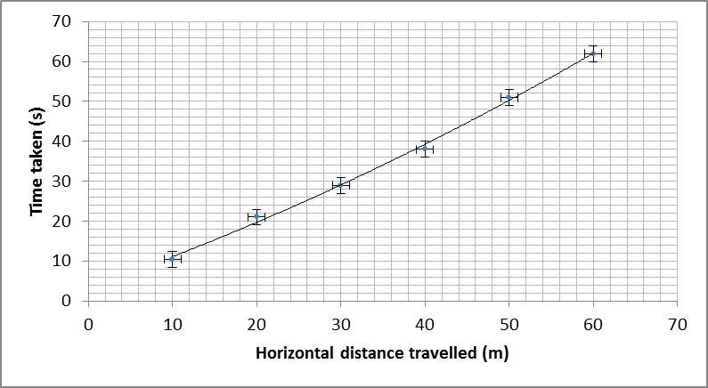

The error bars show the complete range that the data may fall into when uncertainty is considered. There may be error bars in the vertical axis, horizontal axis or both. The line of best fit is only reliable if it passes through all the error bars.

  - Your turn: Use the information below to determine the uncertainty and make a suitable graph.
John was trying to determine whether his solar powered car maintained a steady velocity on a flat surface. John measured out various length of straight track using a trundle wheel (a device that clicks every 1 m that John walks). He timed how long the solar car took to complete each length by timing with a stop watch that gave readings to two decimal places (e.g.: 12.32 sec).

Distance of track (m) | Time Taken (s)
1 | 0.52
5 | 1.21
10 | 3.02
15 | 6.21
20 | 10.20

What is the uncertainty in the distance measured? What is the reason for your choice?

What is the uncertainty in the time measured? What is the reason for your choice?

Advanced use of Uncertainty and Error Bars
To determine how fast an object is moving we use the formula$v=\frac{distance}{time}$. If both distance and time have an uncertainty, how does this affect the value of the velocity? Is it also uncertain?

The answer is “yes”. Not having a precise number for distance or time will result in not having a precise number for the calculated velocity. Here are the rules for determining the uncertainty of a calculated value from uncertain data

- Calculating the percentage uncertainty
% uncertainty of A = $\frac{absolute uncertainty ofA}{value of A}*100$
E.g.: The percentage uncertainty of a time recorded as 13.4 sec due to human reaction time of ±0.2 s
$\% uncertainty of t=\frac{0.2}{13.4}*100=1.49 \%$

- Uncertainty when adding/subtracting data
$uncertainty \left(A±B\right)=uncertainty\left(A\right)+uncertainty(B)$
E.g.: The uncertainty of a change in temperature when the initial temperature is 52ºC and the final temperature is 23ºC using a thermometer with 1ºC increments
$uncertainty of T_{final}-T_{initial}=0.5+0.5= ±1^{o}C$

- Uncertainty when multiplying/dividing data
$\% uncertainty \left(A*B\right)=\% uncertainty \left(A\right)+\% uncertainty (B)$
E.g.: The uncertainty of the area of a rectangular room whose sides are measured to be 3.5 m and 2.2 m using a measuring tape with 10 cm increments.
$\% uncertainty L=\frac{0.05}{3.5}*100=±1.43\%$
$\% uncertainty W=\frac{0.05}{2.2}*100=±2.27\%$
$\% uncertainty of Area \left(L*W\right)=1.43\%+2.27\%=±3.7\%$

(Note: This can be turned into an absolute error using the formula from 1.)
$Uncertainty of Area=\left(Value ofArea\right)*\frac{\% uncertainty}{100}$
$Value of Area = L * W = 3.5 * 2.2 = 7.7 m^{2}$
$∴Uncertainty of Area=7.7*\frac{3.7}{100}=±0.28 m^{2}$

  - Your turn: Determine value and the absolute uncertainty of the following calculated values:
- The difference in time between two sprinters who are recorded as finishing at 10.24 sec and 10.65 sec using electronic timing system precise to ±0.01 sec.

- The area of a soccer pitch measured to be 28 m long and 13 m wide using a trundle wheel (device that clicks every time it moves 1 metre).

- The volume of a cube measured to have sides of 12 cm long. This was measured using a ruler with 1 cm increments.

Linearising data for graphical analysis

A graph is useful for visually representing trends between variables. Imagine you have an ice cream shop located 2.5 km from the beach. The graph below shows the relationship between max daily temperature and ice creams you sell each day.

This graph shows us that more ice creams are sold on hotter days and the relationship is not linear. However we could do better. An ice cream salesman veteran tells you he has found the relationship you are looking for:
$$\frac{I}{d}={ T}^{2}$$
$$I is ice cream sold$$
$$d is distance from beach \left(km\right)$$
$$T is daily maximum temperature (^{0}C)$$

We can prove whether your shop data agrees with this relationship by adjusting the data to check whether $I∝T^{2}$ ($∝$ means “proportional to”).

  - Linearising data

To linearise the data (and the same steps apply to any type of data and relationships):

- Take the formula and ensure that the dependent variable is the subject of the equation
E.g.:
$I=d T^{2}$ ($I$ is the dependent variable)
- Compare the formula to the equation of a straight line
$$I=d T^{2}$$
$$y=m x+c$$
- Make a connection between the $y$ and $x$ variables with the original formula to determine the values to use on the vertical and horizontal axes respectively.
$$I=d T^{2}$$
$$y=m x+c$$
Since $T$ is the independent variable, it must be connected with the horizontal axis. Comparing the two formula reveals the horizontal axis should have $T^{2}$ values ($x=T^{2}$) if it is to be linear. No change needs to be made to $I$ values since $y=I$. There is no +c value in this ice cream-temp relationship but there could be in other relationships.
Here is the raw data. Complete the final column to find $T^{2}$
Temperature (deg C) | Ice cream sold | Temperature squared (deg C²)
12 | 360
14 | 490
18 | 810
21 | 1103
26 | 1690
33 | 2723
38 | 3610
41 | 4203

Make a plot of $I$against $T^{2}$

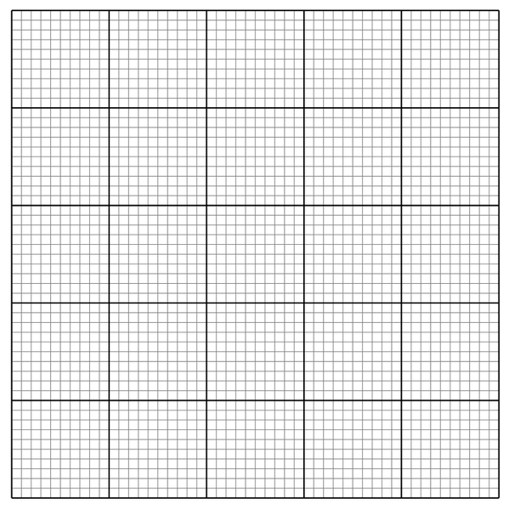

If it is linear, this shows that ice cream sold is proportional to temperature squared ($I∝T^{2}$). When $T^{2}$ doubles then $I$ doubles.

This information helps establish the formula showing the relationship between$I$ and $T$, but we are not finished. All we know for certain is $I=kT^{2}$, where $k$ is some constant. Next we find what $k$ is.

  - Obtaining information from the gradient and/or intercepts

Having a linear graph allows us to both calculate and find physical meaning from the gradient. The intercepts with the vertical axis may mean something too. Take a look at our ice cream formula and compare it to the equation of a straight line.

$$I=d T^{2}+0$$
$$y=m x+c$$

Just as the horizontal and vertical axis variables can be compared to $x$ and $y$, the gradient $m$ can be compared to any constants that the independent variable is multiplied by. In this case the independent variable $T^{2}$ is multiplied by $d$. This makes $d$ the gradient of the graph. The gradient must be a constant in a linear graph; we know this is true in this case since the shop is in a fixed location.
$$gradient=d (distance from beach)$$

Find the gradient of your graph.

Knowing your shop is 2.5 km from the beach, does it appear that the ice cream and temperature relationship matches your data?

Because the ice cream formula did not have any $+c$ value, no information can be obtained from the vertical axis intercept. Hopefully the intercept is close to (0,0).

  - Your turn: Determine what variable you would plot on the horizontal axis and vertical axis to make the graph linear. Also describe what physical meaning the gradient and vertical intercept have, if anything.
Formula | Variable types | Horizontal axis | Vertical axis | Gradient | Vertical Intercept
$$E=\frac{hc}{λ}-W$$ | Independent: λ  Dependent: $E$ | $$\frac{1}{λ}$$ | $$E$$ | $$hc$$ | $$-W$$
$$v=u+at$$ | Independent: $t$  Dependent: $v$
$$rqB=mv$$ | Independent: $B$  Dependent: $r$
$$B=\frac{μ_{0}}{2π}×\frac{I}{r}$$ | Independent: $r$  Dependent: $B$

Here is the data for the $rqB=mv$ experiment. Use the additional column to adjust the data and make a linear plot on the next page.
B (T) | r × 10⁻⁶ (m)
0.001 | 6.8
0.002 | 3.4
0.003 | 2.3
0.004 | 1.7
0.005 | 1.4
0.006 | 1.1

In this experiment:
$$q is charge of an electron=1.6*{10}^{-19} C$$
$$m is the mass of an electron=9.11*{10}^{-31} kg$$
$$v is the velocity of the electron= ?$$

Calculate the gradient of the graph. Then use the gradient to find the velocity of the electron. Note: If you at any stage refer to and use any values straight from the table then you are doing it wrong and you won't get full marks.

